**In 1967, the CIA Created the Label "Conspiracy Theorists" ... to Attack Anyone Who Challenges the "Official" Narrative**

[George Washington's picture](http://www.zerohedge.com/users/george-washington)

Submitted by [George Washington](http://www.zerohedge.com/users/george-washington) on 02/23/2015 19:26 -0500

**Conspiracy Theorists USED TO Be Accepted As Normal**

Democracy and free market capitalism were [founded](http://www.washingtonsblog.com/2012/09/america-and-western-civilization-as-a-whole-was-founded-on-a-conspiracy-theory.html) on conspiracy theories.

The [Magna Carta, the Constitution and Declaration of Independence](http://www.washingtonsblog.com/2012/09/america-and-western-civilization-as-a-whole-was-founded-on-a-conspiracy-theory.html) and other founding Western documents were based on conspiracy theories.

[Greek democracy and free market capitalism](http://www.washingtonsblog.com/2012/09/america-and-western-civilization-as-a-whole-was-founded-on-a-conspiracy-theory.html) were also based on conspiracy theories.

But those were the bad old days …Things have now changed.

**The CIA Coined the Term Conspiracy Theorist In 1967**

That all changed in the 1960s.

Specifically, in April 1967, the CIA [wrote](https://books.google.com/books?id=TilCeCKDujQC&pg=PA200&lpg=PA200&dq=cia+%22Conspiracy+on+the+large+scale+often+suggested+would+be+impossible+to+conceal+in+the+United+States.%22&source=bl&ots=R3UDlJbyo3&sig=FGKbeXrsfpMMDxWQSozPvh0ic20&hl=en&sa=X&ei=95fqVIb_ONXnoAT-pIDQDg&ved=0CEQQ6AEwBg#v=onepage&q=cia%20%22Conspiracy%20on%20the%20large%20scale%20often%20suggested%20would%20be%20impossible%20to%20conceal%20in%20the%20United%20States.%22&f=false) a dispatch which coined the term “conspiracy theories” … and recommended methods for discrediting such theories. The dispatch was marked “psych” –  short for “psychological operations” or disinformation – and “CS” for the CIA’s “Clandestine Services” unit.

The dispatch was produced in responses to a Freedom of Information Act request by the New York Times in 1976.

The dispatch states:

*2. This trend of opinion is a matter of concern to the U.S. government, including our organization.*

*\*\*\**

*The aim of this dispatch is to provide material* ***countering and discrediting the claims of the conspiracy theorists****, so as to inhibit the circulation of such claims in other countries. Background information is supplied in a classified section and in a number of unclassified attachments.*

*3. Action. We do not recommend that discussion of the [conspiracy] question be initiated where it is not already taking place. Where discussion is active addresses are requested:*

*a. To discuss the publicity problem with and friendly elite contacts (especially politicians and editors) , pointing out that the [official investigation of the relevant event] made as thorough an investigation as humanly possible, that the charges of the critics are without serious foundation, and that further speculative discussion only plays into the hands of the opposition. Point out also that parts of the conspiracy talk appear to be deliberately generated by …  propagandists. Urge them to use their influence to discourage unfounded and irresponsible speculation.*

*b. To****employ propaganda assets to and refute the attacks of the critics. Book reviews and feature articles are particularly appropriate for this purpose.****The unclassified attachments to this guidance should provide useful background material for passing to assets. Our ploy should point out, as applicable, that the critics are (I)****wedded to theories adopted before the evidence was in****, (II)****politically interested****, (III)****financially interested****, (IV) hasty and inaccurate in their research, or (V)****infatuated with their own theories****.*

*\*\*\**

*4. In private to media discussions not directed at any particular writer, or in attacking publications which may be yet forthcoming, the following arguments should be useful:*

*a.****No significant new evidence has emerged****which the Commission did not consider.*

*\*\*\**

*b. Critics usually overvalue particular items and ignore others. They****tend to place more emphasis on the recollections of individual witnesses****(which are less reliable and more divergent–and hence offer more hand-holds for criticism) …*

*\*\*\**

*c.****Conspiracy on the large scale often suggested would be impossible to conceal****in the United States, esp. since informants could expect to receive large royalties, etc.*

*\*\*\**

*d. Critics have often been enticed by a form of intellectual pride:****they light on some theory and fall in love with it****; they also scoff at the Commission because it did not always answer every question with a flat decision one way or the other.*

*\*\*\**

*f. As to charges that the Commission’s report was a rush job, it emerged three months after the deadline originally set. But to the degree that the Commission tried to speed up its reporting, this was largely due to the pressure of****irresponsible speculation****already appearing, in some cases coming from the same critics who, refusing to admit their errors, are now putting out new criticisms.*

*g.****Such vague accusations as that “more than ten people have died mysteriously” can always be explained in some natural way****….*

*5. Where possible, counter speculation by encouraging reference to the Commission’s Report itself. Open-minded foreign readers should still be impressed by the care, thoroughness, objectivity and speed with which the Commission worked.****Reviewers of other books might be encouraged to add****to their account the idea****that, checking back with the report itself, they found it far superior to the work of its critics.***

Here are screenshots of part of the memo:

[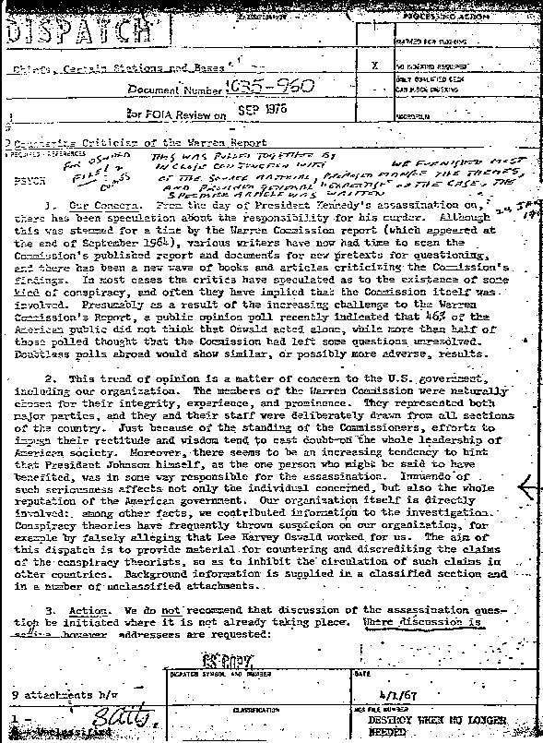](http://www.washingtonsblog.com/wp-content/uploads/2015/02/CIA-conspiracy.jpg)[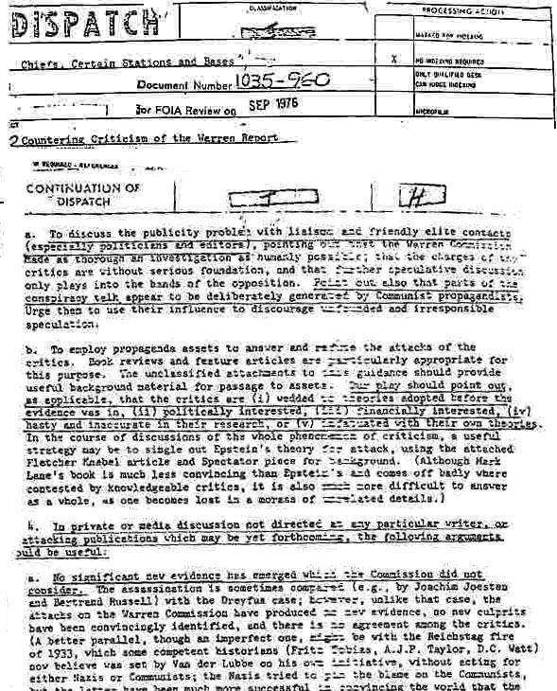](http://www.washingtonsblog.com/wp-content/uploads/2015/02/CIA-conspiracy2.jpg)

Summarizing the tactics which the CIA dispatch recommended:

* Claim that it would be impossible for so many people would keep quiet about such a big conspiracy
* Have [people friendly to the CIA](http://www.washingtonsblog.com/2015/01/propaganda.html) attack the claims, and point back to “official” reports
* Claim that eyewitness testimony is unreliable
* Claim that this is all old news, as “no significant new evidence has emerged”
* Ignore conspiracy claims unless discussion about them is already too active
* Claim that it’s irresponsible to speculate
* Accuse theorists of being wedded to and infatuated with their theories
* Accuse theorists of being politically motivated
* Accuse theorists of having financial interests in promoting conspiracy theories

In other words, the CIA’s clandestine services unit created the arguments for attacking conspiracy theories as unreliable in the 1960s as part of its psychological warfare operations.

**But Aren’t Conspiracy Theories – In Fact – Nuts?**

Forget Western history and CIA dispatches … aren’t conspiracy theorists nutty?

In fact, conspiracies are so common that judges are trained to look at conspiracy allegations as [just another legal claim](http://www.washingtonsblog.com/2009/10/time-magazines-justin-fox-some-financial-market-conspiracies-are-real.html) to be disproven or proven*based on the specific evidence*:

[*Federal*](http://www.law.cornell.edu/uscode/18/usc_sec_18_00000371----000-.html)*and all 50*[*state’s*](http://www.google.com/search?hl=en&suggon=0&client=firefox-a&rls=org.mozilla%3Aen-US%3Aofficial&hs=vXH&q=state+penal+code+conspiracy+felony&btnG=Search)***codes****include specific statutes addressing conspiracy, and providing the punishment for people who commit conspiracies.*

*But let’s examine what the people trained to weigh evidence and reach conclusions think about “conspiracies”. Let’s look at what American* ***judges****think.*

*Searching*[*Westlaw*](http://www.westlaw.com/)*, one of the 2 primary legal research networks which attorneys and judges use to research the law, I searched for court decisions including the word “Conspiracy”. This is such a common term in lawsuits that it overwhelmed Westlaw.*

*Specifically, I got the following message:*

*“Your query has been intercepted because it may retrieve a large number of documents.”*

*From experience, I know that this means that there were potentially millions or many hundreds of thousands of cases which use the term. There were so many cases, that Westlaw could not even start processing the request.*

*So I searched again, using the phrase “Guilty of Conspiracy”. I hoped that this would not only narrow my search sufficiently that Westlaw could handle it, but would give me cases where the judge actually found the defendant guilty of a conspiracy. This pulled up exactly 10,000 cases — which is the maximum number of results which Westlaw can give at one time. In other words, there were more than 10,000 cases using the phrase “Guilty of Conspiracy” (maybe there’s a way to change my settings to get more than 10,000 results, but I haven’t found it yet).*

*Moreover, as any attorney can confirm, usually only appeal court decisions are published in the Westlaw database. In other words, trial court decisions are rarely published; the only decisions normally published are those of the courts which hear appeals of the trial. Because only a very small fraction of the cases which go to trial are appealed, this logically means that the number of guilty verdicts in conspiracy cases at trial must be much, much larger than 10,000.*

*Moreover, “Guilty of Conspiracy” is only one of many possible search phrases to use to find cases where the defendant was found guilty of a lawsuit for conspiracy. Searching on Google, I got*[*3,170,000 results*](http://www.google.com/search?hl=en&suggon=0&client=firefox-a&rls=org.mozilla%3Aen-US%3Aofficial&hs=ZW6&q=%22guilty+of+conspiracy%22&btnG=Search)*(as of yesterday) under the term “Guilty of Conspiracy”,*[*669,000 results*](http://www.google.com/search?q=%22convictions+for+conspiracy%22&ie=utf-8&oe=utf-8&aq=t&rls=org.mozilla:en-US:official&client=firefox-a)*for the search term “Convictions for Conspiracy”, and*[*743,000 results*](http://www.google.com/search?hl=en&suggon=0&client=firefox-a&rls=org.mozilla%3Aen-US%3Aofficial&hs=M9Q&q=%22convicted+for+conspiracy%22&btnG=Search)*for “Convicted for Conspiracy”.*

*Of course, many types of conspiracies are called other things altogether. For example, a long-accepted legal doctrine makes it illegal for two or more companies to conspire to fix prices, which is called “Price Fixing” (*[*1,180,000 results*](http://www.google.com/search?q=%22price+fixing%22&ie=utf-8&oe=utf-8&aq=t&rls=org.mozilla:en-US:official&client=firefox-a)*).*

*Given the above, I would extrapolate that there have been hundreds of thousands of convictions for criminal or civil conspiracy in the United States.*

*Finally, many crimes go unreported or unsolved, and the perpetrators are never caught. Therefore, the actual number of conspiracies committed in the U.S. must be even higher.*

*In other words,* ***conspiracies are committed all the time*** *in the U.S., and many of the conspirators are caught and found guilty by American courts. Remember, Bernie Madoff’s Ponzi scheme was a conspiracy theory.*

*Indeed, conspiracy is a very well-recognized crime in American law, taught to every first-year law school student as part of their basic curriculum.****Telling a judge that someone has a “conspiracy theory” would be like telling him that someone is claiming that he trespassed on their property, or committed assault, or stole his car. It is a fundamental legal concept****.*

*Obviously, many conspiracy allegations are false (if you see a judge at a dinner party, ask him to tell you some of the crazy conspiracy allegations which were made in his court). Obviously, people will either win or lose in court depending on whether or not they can prove their claim with the available evidence. But not all allegations of trespass, assault, or theft are true, either.*

*Proving a claim of conspiracy is no different from proving any other legal claim, and the mere label “conspiracy” is taken no less seriously by judges.*

It’s not only [Madoff](http://www.usatoday.com/money/industries/brokerage/2009-08-11-madoff-cfo_N.htm). The heads of [Enron](http://www.msnbc.msn.com/id/12968481/) were found guilty of conspiracy, as was the head of [Adelphia](http://www.msnbc.msn.com/id/5396406). Numerous lower-level government officials have been found guilty of conspiracy. See [this](http://fas.org/irp/news/2009/05/doj051309.html), [this](http://www.justice.gov/atr/public/press_releases/2009/243940.htm), [this](http://cityroom.blogs.nytimes.com/2009/10/28/former-nyc-tv-official-pleads-guilty-to-conspiracy/), [this](http://www.washingtonsblog.com/2009/02/not-just-a-few-bad-apples-corruption-is-systemic-in-america.html) and [this](http://www.highbeam.com/doc/1G1-123412764.html).

Time Magazine’s financial columnist Justin Fox [writes](http://curiouscapitalist.blogs.time.com/2009/10/01/wall-streeters-like-conspiracy-theories-always-have/):

*Some financial market conspiracies are real …*

*Most good investigative reporters are conspiracy theorists, by the way.*

And what about the NSA and the tech companies that have cooperated with them?

**But Our *Leaders* Wouldn’t Do That**

While people might admit that corporate executives and low-level government officials might have engaged in conspiracies – they may be strongly opposed to considering that the wealthiest or most powerful might possibly have done so.

But powerful insiders have long admitted to conspiracies. For example, Obama’s Administrator of the Office of Information and Regulatory Affairs, Cass Sunstein,[wrote](http://papers.ssrn.com/sol3/papers.cfm?abstract_id=1084585" \o "admits" \t "_blank):

*Of course some conspiracy theories, under our definition, have turned out to be true. The Watergate hotel room used by Democratic National Committee was, in fact, bugged by Republican officials, operating at the behest of the White House. In the 1950s, the Central Intelligence Agency did, in fact, administer LSD and related drugs under Project MKULTRA, in an effort to investigate the possibility of “mind control.” Operation Northwoods, a rumored plan by the Department of Defense to simulate acts of terrorism and to blame them on Cuba, really was proposed by high-level officials ….*

**But Someone Would Have Spilled the Beans**

A common defense to people trying sidetrack investigations into potential conspiracies is to say that “someone would have spilled the beans” if there were really a conspiracy.

But famed whistleblower Daniel Ellsberg [explains](http://www.dailykos.com/story/2006/1/22/11595/1945):

*It is a commonplace that “you can’t keep secrets in Washington” or “in a democracy, no matter how sensitive the secret, you’re likely to read it the next day in the New York Times.” These truisms are flatly false. They are in fact cover stories, ways of flattering and misleading journalists and their readers, part of the process of keeping secrets well. Of course eventually many secrets do get out that wouldn’t in a fully totalitarian society. But the fact is that the overwhelming majority of secrets do not leak to the American public. This is true even when the information withheld is well known to an enemy and when it is clearly essential to the functioning of the congressional war power and to any democratic control of foreign policy.****The reality unknown to the public and to most members of Congress and the press is that secrets that would be of the greatest import to many of them can be kept from them reliably for decades by the executive branch, even though they are known to thousands of insiders.***

History proves Ellsberg right. For example:

* [One hundred and thirty thousand (130,000)](http://en.wikipedia.org/wiki/Manhattan_Project) people from the U.S., UK and Canada worked on the Manhattan Project. But it was kept secret for years
* A BBC documentary [shows](http://www.bbc.co.uk/radio4/history/document/document_20070723.shtml) that:

*There was “a planned coup in the USA in 1933 by a group of right-wing American businessmen . . . . The coup was aimed at toppling President Franklin D Roosevelt with the help of half-a-million war veterans. The plotters, who were alleged to involve some of the most famous families in America, (owners of Heinz, Birds Eye, Goodtea, Maxwell Hse & George Bush’s Grandfather, Prescott) believed that their country should adopt the policies of Hitler and Mussolini to beat the great depression”*

*Moreover,*[*“the tycoons told General Butler the American people would accept the new government because they controlled all the newspapers.”*](http://dailykos.com/storyonly/2007/7/25/17852/8697)*Have you ever heard of this conspiracy before? It was certainly a very large one. And if the conspirators controlled the newspapers then, how much worse is it today with media consolidation?*

* [7 out of the 8 giant, money center banks went bankrupt](http://www.washingtonsblog.com/2009/10/the-largest-u-s-banks-have-repeatedly-gone-bankrupt-due-to-wild-speculation-the-fed-blessed-the-speculation-then-helped-cover-up-the-bankruptcies.html) in the 1980′s during the “Latin American Crisis”, and the government’s response was to cover up their insolvency. That’s a cover up lasting *several decades*
* Banks have been involved in [systematic criminal behavior](http://www.washingtonsblog.com/2014/05/6-years-financial-crisis-hit-big-banks-still-committing-massive-crimes.html), and have manipulated [every single market](http://www.washingtonsblog.com/2014/12/big-banks-conspire-bp-oil-company-manipulate-market.html)
* Governments have been [covering up nuclear meltdowns for fifty years](http://www.washingtonsblog.com/2011/03/governments-have-been-covering-up.html) to protect the nuclear industry. Governments have colluded to cover up the severity of [numerous other environmental accidents](http://www.washingtonsblog.com/2010/08/government-is-dealing-with-oil-spill.html). For many years, Texas officials [intentionally under-reported the amount of radiation in drinking water to avoid having to report violations](http://www.khou.com/home/-Texas-politicians-knew-agency-hid-the-amount-of-radiation-in-drinking-water-122205439.html)
* The government’s spying on Americans began [before 9/11](http://blog.wired.com/27bstroke6/2007/10/nsa-asked-for-p.html) (confirmed [here](http://www.bloomberg.com/apps/news?pid=20601087&sid=abIV0cO64zJE) and [here](http://rawstory.com/news/2007/ATT_engineer_says_Bush_Administration_sought_1216.html). And see [this](http://web.archive.org/web/20060213222729/http:/news.yahoo.com/s/ap/20060204/ap_on_go_pr_wh/ford_era_spying_1).) But the public didn’t learn about it until many years later. Indeed, the the New York Times [delayed the story](http://www.fair.org/index.php?page=2798) so that it would not affect the outcome of the 2004 presidential election
* The decision to launch the Iraq war was made [before 9/11](http://crooksandliars.com/karoli/new-documents-show-bush-administration-plan). Indeed, former CIA director George Tenet said that the White House [wanted to invade Iraq long before 9/11, and inserted “crap” in its justifications for invading Iraq.](http://www.washingtonpost.com/wp-dyn/content/article/2007/04/27/AR2007042700550.html?nav=most_emailed) Former Treasury Secretary Paul O’Neill – who sat on the National Security Council – also [says](http://www.cnn.com/2004/ALLPOLITICS/01/10/oneill.bush/) that Bush planned the Iraq war before 9/11. And top British officials [say](http://rawstory.com/2009/11/discussed-iraq-regime-change-month-bush-office-british/) that the U.S. discussed Iraq regime change one month after Bush took office. Dick Cheney apparently even made Iraqi’s oil fields a national security priority [before 9/11](http://www.washingtonsblog.com/2008/07/did-cheney-and-the-oil-bigs-plan-the-iraq-war-before-911.html). And it has now been shown that [a handful of people](http://web.archive.org/web/20060215201936/http:/www.newyorker.com/fact/content/?031027fa_fact) were responsible for willfully ignoring the evidence that Iraq lacked weapons of mass destruction. These facts have only been publicly disclosed recently. Indeed, Tom Brokaw [said](http://www.huffingtonpost.com/greg-mitchell/tom-brokaw-defends-war-co_b_104636.html), “*All* wars are based on propaganda.” A concerted effort to produce propaganda is a conspiracy

Moreover, high-level government officials and insiders have *admitted* to dramatic conspiracies after the fact, including:

* [Supporting terrorists to promote geopolitical goals](http://www.washingtonsblog.com/2012/09/sleeping-with-the-devil-how-u-s-and-saudi-backing-of-al-qaeda-led-to-911.html)
* [Supporting false flag terror](http://www.washingtonsblog.com/2015/02/x-admitted-false-flag-attacks.html)

The admissions did not occur until *many decades* after the events.

These examples show that it is possible to keep conspiracies secret for a long time, without anyone “spilling the beans”.

In addition, to anyone who knows how covert military operations work, it is obvious that segmentation on a “need-to-know basis”, along with deference to command hierarchy, means that a couple of top dogs can call the shots and most people helping *won’t even know* the big picture at the time they are participating.

Moreover, those who think that co-conspirators will brag about their deeds forget that people in the military or intelligence or who have huge sums of money on the line can be very disciplined. They are not likely to go to the bar and spill the beans like a down-on-their-luck, second-rate alcoholic robber might do.

Finally, people who carry out covert operations may do so for ideological reasons — believing that the “ends justify the means”. Never underestimate the conviction of an ideologue.

**Conclusion**

The bottom line is that some conspiracy claims are nutty and some are true. Each has to be judged on its own facts.

Humans have a tendency to try to explain random events through seeing patterns … that’s how our brains our wired. Therefore, we have to test our theories of connection and causality against the cold, hard facts.

On the other hand, the old saying by Lord Acton is true:

*Power tends to corrupt, and absolute power tends to corrupt absolutely.*

Those who operate without checks and balances – and without the disinfectant sunlight of public scrutiny and accountability – tend to act in their own best interests … and the little guy gets hurt.

The early Greeks knew it, as did those who forced the king to sign the Magna Carta, the Founding Fathers and the father of modern economics. We should remember this important tradition of Western civilization.

*Postscript: The ridicule of****all****conspiracy theories is really just an*[*attempt to diffuse criticism of the powerful*](http://www.washingtonsblog.com/2010/02/ridicule-of-conspiracy-theories-focuses-on-diffusing-criticism-of-the-powerful.html)*.*

*The wealthy are not worse than other people … but they are*[*not necessarily better*](http://www.washingtonsblog.com/2011/08/psychologists-%E2%80%9Cthe-idea-of-nobless-oblige-or-trickle-down-economics-%E2%80%A6-is-bull-our-data-say-you-cannot-rely-on-the-wealthy-to-give-back-the-%E2%80%98thousand-points-of-light%E2%80%99.html) *either. Powerful leaders may not be bad people … or they* [*could be sociopaths*](http://www.washingtonsblog.com/2012/07/why-dont-the-psychopaths-on-wall-street-and-in-d-c-show-remorse-for-their-destructive-actions-and-why-dont-we-stop-them.html)*.*

*We must judge each by his or her actions, and not by preconceived stereotypes that they are all saints acting in our best interest or all scheming criminals.*

And see ...

[**The Troll’s Guide to Internet Disruption**](http://www.washingtonsblog.com/2015/02/trolls-guide-internet-disruption.html)